**1 INTRODUCTION**

**1.1 Overview**

A well-designed book cover is important because it serves as the face of the book, and entices readers to purchase it. A book cover uses design elements like color, font, images or illustrations to reflect key themes that are relevant to the text, and helps readers to understand a little more of what it’s about.

**1.2 Purpose**

The purpose of book cover using is to draw the attention of your potential readers away from all those other tomes and novellas and sell them on the idea that your page-turner is the next book they need on their nightstand.

**2 PROBLEM DEFINITION AND DESIGN THINKING**

**2.1 Empathy map**

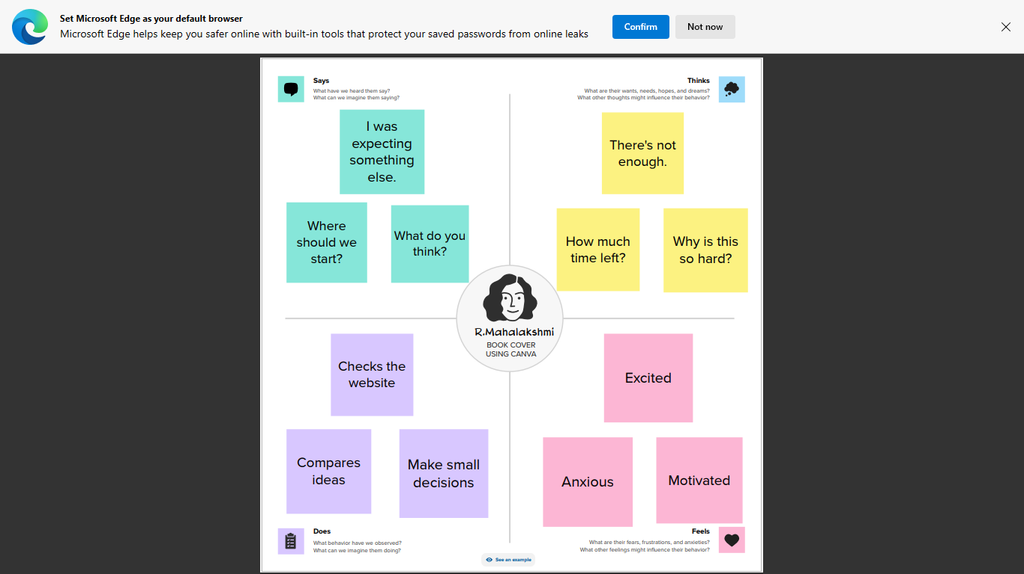

**2.2 Ideation & Brainstorming map**

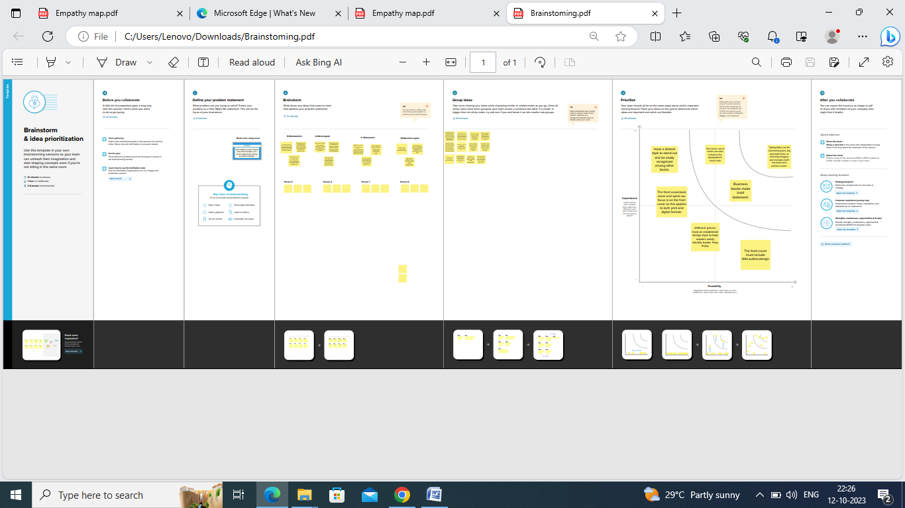

**RESULT**

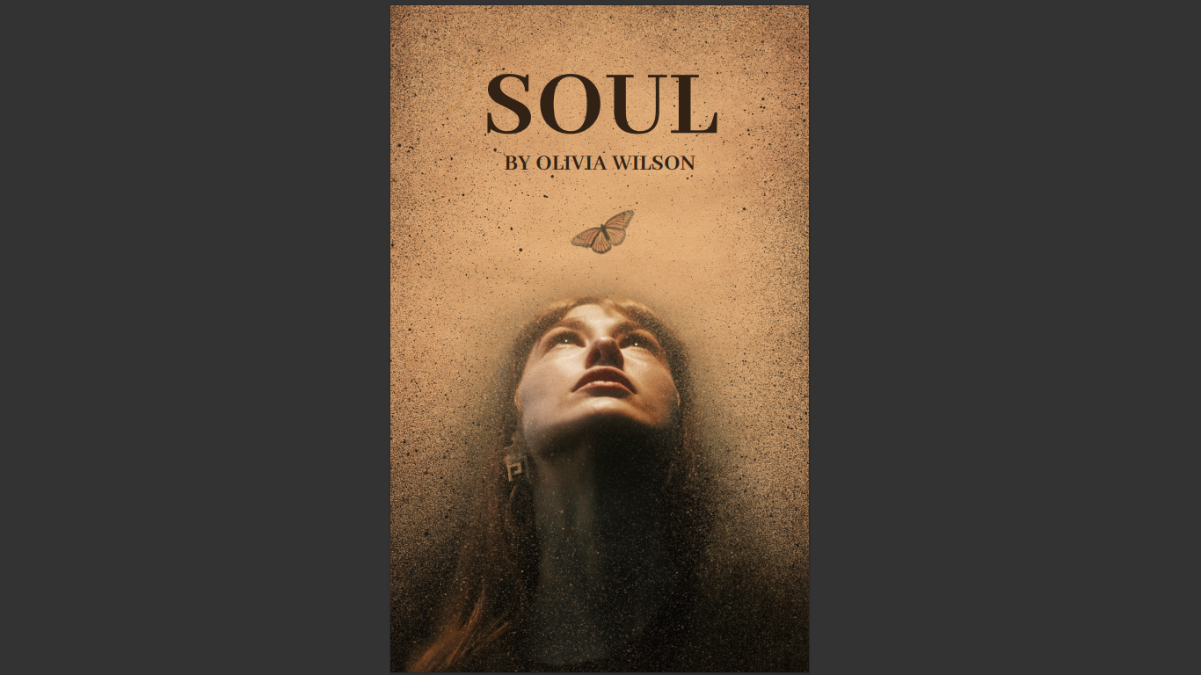

**ADVANTAGES AND DISADVANTAGES**

1. It's great for crafting books with illustrations and photographs, but it can also be used to put together short stories, poetry, novels, and other works that are heavier on the text.
2. It's easy to use. Canva is a drag-and-drop design platform, so you don't need any prior design experience to create a professional-looking book cover.
3. Canva allows users to export their designs in various formats, including JPG, PNG, and PDF. However, the platform’s export settings can be somewhat limited.
4. While Canva is a standalone design tool, many graphic designers use multiple tools in their workflow. In this context, Canva’s compatibility with other design tools can be limited.

**APPLICATION**

Canva's free book cover maker is ridiculously easy to use – even for the novice or not-so-tech-savvy writer. Our book cover maker allows you to choose from hundreds of layouts, making it easier than ever to create a memorable cover.

**CONCLUSION**

A well-designed book cover is important because it serves as the face of the book, and entices readers to purchase it. A book cover uses design elements like color, font, images or illustrations to reflect key themes that are relevant to the text, and helps readers to understand a little more of what it’s about.